Annual Activities Report
2007-08

Atma Sanchay Project
This year we motivate around 1000 slum dwellers and BPL women to open Zero Balance saving account in Nationalised Bank Canara Bank, Tuialadungri and programme is on going in BAGBERA, East Singhbhum, where a collection centre is established . Till the day Women particularly daily bread earners have deposited 2 lakhs.

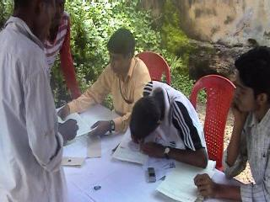
Account opening under ATMA SANCHAY Project in Bagbera , Jamshedpur

Women Empowerment
SPARSH run Working Women’s Hostel. Department of Social Welfare supported this programmed on no profit no loss basis. It is our SHAKTI Project. The Hostel is a capacity of 68 inmates who have all basic facilities within the building. We provide personality development programme and Yoga Classes in regular interval. Apart from this we conducted training programme

Welfare Project ‘SRIJAN’

Last Year, We are in verge of different programme for sustained development among poor, underprivileged class and particularly women and BPL families. We supports government particularly DRDA, East Singhbhum under SRIJAN project for design development marketing of self help group products. General Secretary attended International Trade Fair, Delhi and Jaipur MELA. Under Shakti Project we support women to empower for self employment. Training Programme conducted in Jamshedpur and Chaibasa . Out of trained 93 women from weaker section of society formed 5 self help groups are linked to DRDA JAMSHEDPUR. Seraikella Kharswan has given a assignment of 300 self help groups in Kharswan Block.
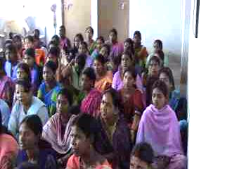

Training of Slum dwellers at Jamshedpur under Shakti Project

UDAN Project- Our rehabilitation project.

We initiated training programme in Observation Home Jamshedpur under UDAN Project. Under this project we tried to motivate the socially misguided children who are under trial in Juvenile court .We provide a platform to divert their mind and support them to earn a square of meal after releasing from observation home. We organized training-cum- workshop in File making and stationary items.Later on we conduct book binding and stationary training in which 26 inmates participated. Training is conducted for 15 days.

24 Children age group of 14 to 18 yrs went through the programme and trained in that. After 30 days training cum production, five inmates are mainstreamed and rehabilitates in deferent place. Our society adopted two of them providing all supports and appointed in organization.

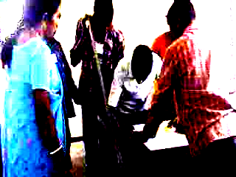
Training at Observation Home
We established “UDAN’ Rehabilitation And Resource Centre” a at KADAMDIHA,kharswan where trained leprosy cured disabled persons
Will produce file and do printing jobs . We are in verge of linkage to The Bank in nearby area. In beginning we started our mission with 23 from surrounding villages.

Total Sanitation Campaign-

SPARSH initiated the TSC Prgramme in 5 districts of Jharkhand and conducted several training, workshop and rally Programme in concerning districts. Basically our NGO involves in remote of Jharkhand especially Kunda and now Simiria of Chatra, Gamey of Giridih, Tonto of Chaibasa, Kuchai of Seraikela- Kharsawan etc.
We organized Children Rally, Kala Jaththa in those areas. In around we covered 600 villages in Sanitation Programme. We established 6 Production centres and three are about to established in other districts.

This year we already installed more than 1800 toilets among BPL and APL families in very low cost. Our Motivators. Panchyat Co-coordinator and Cluster Co-ordinator did awareness campaign of five sanitation indicators in village areas. Capacity building programme has been taken place in different districts, phase wise.

Education

In this financial year, under Gurukul Project we are working on education project in different districts Chatra and Dhanbad along with Chaibasa. In Chaibasa our organization adopted KERA ORIYA HIGH SCHOOL, supporting to affiliation to the board.It is run by experimental basis in remote tribal areas where formal high school is far away from children reach. We surveyed in two districts for education project gathering information of drop out or never enrolled children. We put the proposal of Setu Schools in Seraikella . The Schools are yet to be start in coming month.
Our organization has supported in annual budget planning of Seraikella and General Secretary participated in State Level Training cum Workshop . He conducted 4 days training programme in District Level training programme. This year we adopted a Inter College Jagdish Singh Memorial College, Mango,East Singhbhum and it have been control by our organization.

SREEKALAPITH

Under IEC activities chhau(MASK Dance) Nukkad(Street) Ballet programme has been organized in East Singhbhum , Jamshedpur . Nippon foundation Chairman Sri Sasakwa appreciated the idea and encourage Through this programme we spread the massage of Leprosy treatment programme and social stigma of this disease. Our ‘Shree Kalapith’ – SPARSH Performing Art Project has developed the Nukkad-ballet for social campaigning. Performance took place in remotes of Jharkhand. Through this programme we enable to motivate the illiterate and ignorant suspected persons to health centre for further assistancse. Our Project Director Guru Makardhwaj Darogha was facilitated for contribution in the field.. SRIKALAPITH, our performing art project organized CHAITRA PRAVA 2007 from 10 April to 12 April 2007 in Seraikella where 24 village’s artists perfomed for three days. Workshop on ‘MAHURI- A Traditional Flute’ was organized during festival in which 22 participants from township participated and given certificate. State Bank Of India sponsored the programme.

International Women’s Day

Sparsh celebrated International Women’s Day on 18 March at Working Women’ Hostel, Sakchi, Plantation is carried out in unused land under Protection of Environment. Inmates and officials participated in group discussion in same campus, More than 35 participants participated and 3 speakers delivered the presentation. Orgnisation has supported 280 women through safe and cheap accommodation in Working Women’s Hostel since last year March. Mostly inmates are working in unorganized or private sectors getting low salary.

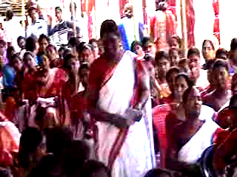
Participants in International Women’s Day

Leprosy SWASTHYA Project

Our organization has initiated innovative programme in rehabilitation of Leprosy cured disabled persons who has been alienated from mainstream of the society. We trained in three days Training cum workshop in File Making and Printing at Seraikella- Adarshmani Pathagar Training Hall. Canara Bank has supported this programme. 30 disabled leprosy cured persons is participated in File making process. Our Resource persons motivate them to belief in own strength and capabilities. This year we will adopt more than 200 such persons.

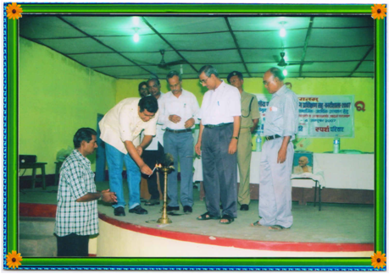
Inauguration of training- cum- workshop in File Making and Printing

Fishery Project

Our organization has distributed 4.5 lakhs seeds among 300 ST and SC persons in NIMDIH Block in SERAIKELLA-KHARSWAN. 9 Panchyats of the block are covered. 300 families who are benefited , basically from Below Poverty Level . We produced seeds in the pond in nearby block Chandil. After few weeks our technical staffs have prepared seeds of fish in the pond.

Health

Our society involved with Pulse Polio Programme in Chaibasa in regular basis. We associated with Malaria Progamme in Chaibasa under Swasthya Project. We distributed 5000 medicated mosquito net among BPL families especially primitive tribe birhore in Seraikela District. After 6 months we re-medicated to distributed net in different blocks of Seraikella.

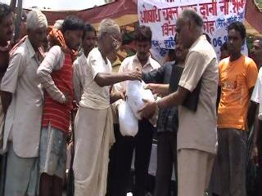
Distribution of Medicated Mosquito Net in Rural Area

GENERAL SECRETARY

